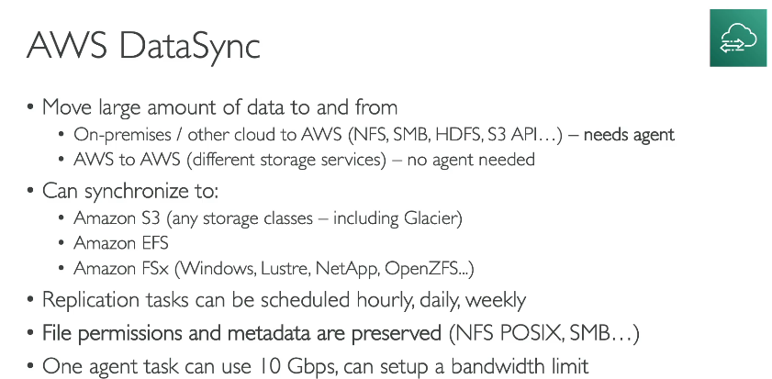
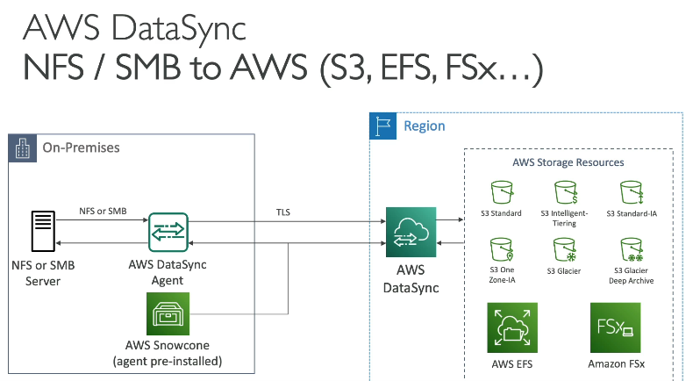

What is AWS DataSync?
AWS DataSync is a managed data transfer service that helps you move large amounts of data quickly and securely between on-premises storage and AWS services, or between AWS storage services.

🔧 Common Use Cases:
- ✅ Migrate data to AWS
  - Example: Move your on-premises file servers (like NFS or SMB) to Amazon S3, EFS, or FSx.

- 🔁 Ongoing data transfers (replication/sync)
  - Example: Sync your production data from on-prem to AWS every night.
- ☁️ Transfer between AWS storage services
  - Example: Move data from S3 to EFS or FSx.
- 🛡️ Backups and archiving
  - Example: Regularly backup on-prem data to S3 Glacier.

📦 What can you transfer data to and from?
Source | Destination
On-premises NFS / SMB | Amazon S3
Amazon EFS | Amazon EFS
Amazon S3 | Amazon FSx
FSx for Windows | Amazon S3
HDFS (Hadoop File System) | Amazon EFS/S3

🧭 How It Works (Simple Steps):
📍 Scenario: Migrate your on-prem files to Amazon S3
- Set Up DataSync Agent (on-prem)
  - Deploy a DataSync agent VM in your on-prem environment.
  - Connect it to your file system.
- Create a Task in DataSync
  - In AWS Console → DataSync → Create task
  - Choose source (e.g., NFS) and destination (e.g., S3 bucket).
- Configure Settings
  - Set filters, schedule (once/daily/hourly), bandwidth limits, etc.
- Run Task
  - DataSync handles secure, fast, and efficient transfer.
  - It verifies data and retries failed transfers.
- Monitor
  - View logs, metrics, and transfer status in the AWS Console or CloudWatch.
